Lab 2. Introduction to PL/SQL And Cursors

**2.1 Identify the problems(if any) in the below declarations:**

DECLARE

V_Sample1 NUMBER(2);

V_Sample2 CONSTANT NUMBER(2) ;

V_Sample3 NUMBER(2) NOT NULL ;

V_Sample4 NUMBER(2) := 50;

V_Sample5 NUMBER(2) DEFAULT 25;

**INPUT :**

DECLARE

V_Sample1 NUMBER(2);

V_Sample2 CONSTANT NUMBER(2) ;

V_Sample3 NUMBER(2) NOT NULL ;

V_Sample4 NUMBER(2) := 50;

V_Sample5 NUMBER(2) DEFAULT 25;

BEGIN

dbms_output.put_line('OK');

End;

/

**OUTPUT**

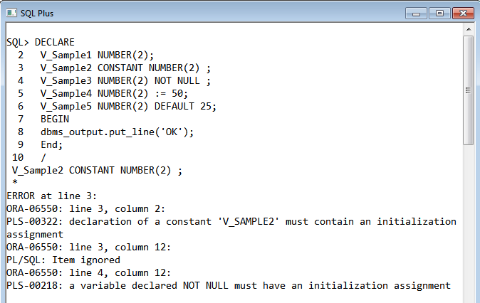

**2.2 The following PL/SQL block is incomplete. Modify the block to achieve requirements as stated in the comments in the block.**

DECLARE --outer block

var_num1 NUMBER := 5;

BEGIN

DECLARE --inner block

var_num1 NUMBER := 10;

BEGIN

DBMS_OUTPUT.PUT_LINE('Value for var_num1:' ||var_num1);

--Can outer block variable (var_num1) be printed here.If Yes,Print the same.

END;

--Can inner block variable(var_num1) be printed here.If Yes,Print the same.

END;

**INPUT :**

<<Outer_Block>>

DECLARE --outer block

var_num1 NUMBER := 5;

BEGIN

<<Inner_Block>>

DECLARE --inner block

var_num1 NUMBER := 10;

BEGIN

DBMS_OUTPUT.PUT_LINE('Value for outer var_num1:' ||Outer_Block.var_num1);

--Can outer block variable (var_num1) be printed here.If Yes,Print the same.

END;

--Inner block variable cannot be accessed outside the inner block.

END;

/

**OUTPUT:**

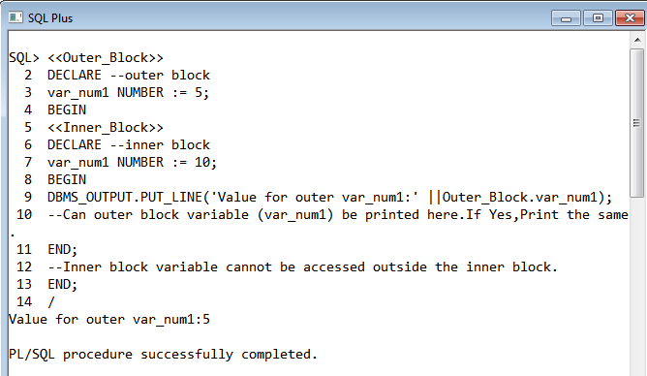

**2.3. Write a PL/SQL block to retrieve all staff (code, name, salary) under specific**

**department number and display the result.**

**INPUT :**

DECLARE

CURSOR C_staff IS

SELECT Staff_Code,Staff_Name,Staff_Sal FROM Staff_Master WHERE Dept_Code=&Dept_Code;

myvar C_staff%ROWTYPE;

BEGIN

OPEN C_staff;

LOOP

FETCH C_staff INTO myvar;

IF C_staff%FOUND THEN

DBMS_OUTPUT.PUT_LINE(myvar.Staff_Code||' '||myvar.Staff_Name||' '||myvar.Staff_Sal);

ELSE

EXIT;

END IF;

END LOOP;

CLOSE C_Staff;

END;

/

**OUTPUT**

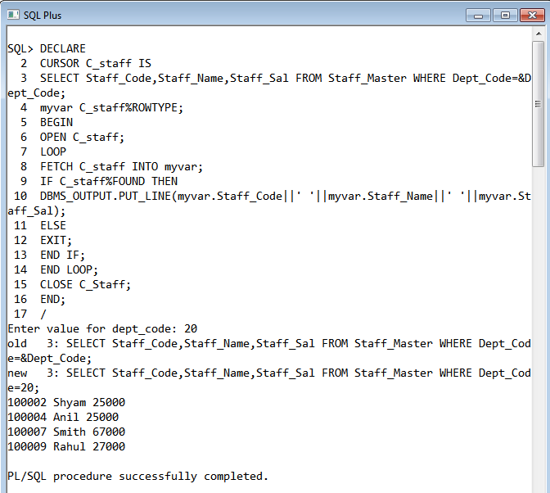

**2.4. Write a PL/SQL block to increase the salary by 30 % or 5000 whichever minimum for**

**a given Department_Code.**

**INPUT:**

DECLARE

CURSOR C_SAL IS

SELECT * FROM STAFF_MASTER WHERE DEPT_CODE=&DEPT_CODE;

VAR C_SAL%ROWTYPE;

BEGIN

OPEN C_SAL;

LOOP

FETCH C_SAL INTO VAR;

EXIT WHEN C_SAL%NOTFOUND;

IF C_SAL%FOUND THEN

IF VAR.STAFF_SAL*0.3 < 5000 THEN

UPDATE STAFF_MASTER SET STAFF_SAL=STAFF_SAL*1.3 WHERE STAFF_CODE=VAR.STAFF_CODE;

ELSE

UPDATE STAFF_MASTER SET STAFF_SAL=STAFF_SAL+5000 WHERE STAFF_CODE=VAR.STAFF_CODE;

END IF;

DBMS_OUTPUT.PUT_LINE(VAR.STAFF_CODE||' '||VAR.STAFF_NAME||' '||VAR.STAFF_SAL);

END IF;

END LOOP;

CLOSE C_SAL;

END;

/

**OUTPUT:**

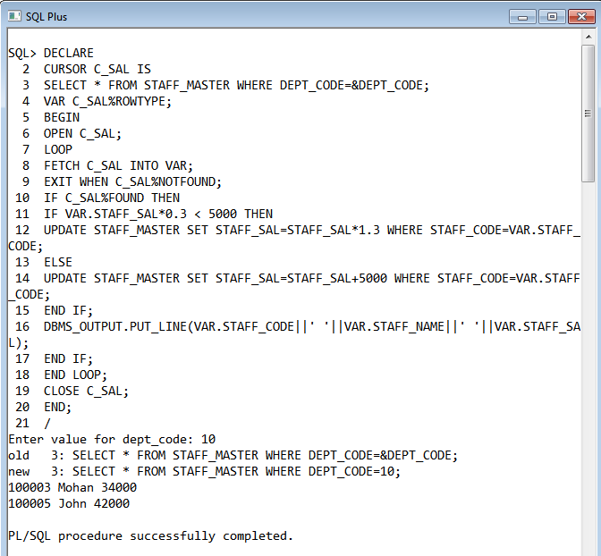

**2.5. Write a PL/SQL block to generate the following report for a given Department code**

**Student_Code Sudent_Name Subject1 Subject2 Subject3 Total Percentage**

**Grade**

For Grade:

Percent >= 80 then grade= A

Percent >= 70 and < 80 then grade= B

Percent >= 60 and < 70 then grade= C

Else D

Student should pass in each subject individually (pass marks 60).

**INPUT:**

DECLARE

Cursor C_result IS

SELECT s1.Student_Code,s1.Student_Name,s2.Subject1,s2.Subject2,s2.Subject3

FROM Student_Master s1,Student_Marks s2 WHERE s1.Student_Code=s2.Student_Code and s1.Dept_Code=&DeptNo;

CURSOR C_Dept IS

SELECT * FROM Department_Master WHERE Dept_Code=&DeptNo;

var C_result%ROWTYPE;

var1 C_Dept%ROWTYPE;

Total NUMBER(5);

Percentage NUMBER(5);

Grade VARCHAR2(2);

counter Number:=0;

BEGIN

OPEN C_Dept;

FETCH C_Dept INTO var1;

IF C_Dept%FOUND THEN

OPEN C_result;

DBMS_OUTPUT.PUT_LINE('Student_Code'||' Student_Name'||' Subject1'||' Subject2'||' Subject3'||' Total'||' Percentage'||' Grade');

LOOP

FETCH C_result INTO var;

IF C_result%NOTFOUND THEN

EXIT;

ELSE

counter:= counter+1;

Total:= var.Subject1 + var.Subject2 + var.Subject3;

Percentage := (Total/300)*100;

IF Percentage >= 80 THEN

Grade:='A';

ELSIF (Percentage >= 70 AND Percentage < 80) THEN

Grade:='B';

ELSIF (Percentage >= 60 AND Percentage < 70) THEN

Grade:='C';

ELSE

Grade:='D';

END IF;

DBMS_OUTPUT.PUT_LINE(var.Student_Code||' '||var.Student_Name||' '||var.Subject1||' '||var.Subject2||' '||var.Subject3||' '||Total||' '||Percentage||' '||Grade);

END IF;

END LOOP;

IF counter=0 THEN

DBMS_OUTPUT.PUT_LINE('There are no students in the department.');

END IF;

CLOSE C_result;

ELSE

DBMS_OUTPUT.PUT_LINE('The Department does not exist.');

END IF;

CLOSE C_Dept;

END;

/

**OUTPUT:**

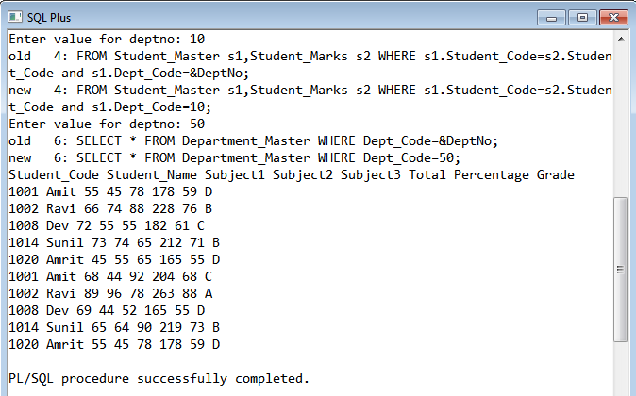

**2.6. Write a PL/SQL block to retrieve the details of the staff belonging to a particular**

**department. Department code should be passed as a parameter to the cursor.**

**INPUT:**

DECLARE

CURSOR C_info IS

SELECT * FROM Staff_Master WHERE Dept_Code = &Dept_Code;

var C_Info%ROWTYPE;

BEGIN

OPEN C_Info;

LOOP

FETCH C_Info INTO var;

EXIT WHEN C_Info%NOTFOUND;

IF C_Info%FOUND THEN

DBMS_OUTPUT.PUT_LINE(var.Staff_Code||' '||var.Staff_Name||' '||var.Design_Code||' '||var.Hiredate||' '||var.Staff_Sal);

END IF;

END LOOP;

CLOSE C_Info;

END;

/

**OUTPUT:**

